Chapter 2, Solution 61

There are three possibilities, but they must also satisfy the current range of 1.2 + 0.06 = 1.26 and 1.2 – 0.06 = 1.14.

- Use R₁ and R₂:
R = 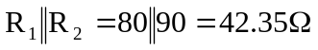
p = i²R = 70W
i² = 70/42.35 = 1.6529 or i = 1.2857 (which is outside our range)
cost = $0.60 + $0.90 = $1.50

- Use R₁ and R₃:
R = 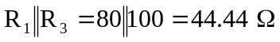
i² = 70/44.44 = 1.5752 or i = 1.2551 (which is within our range), cost = $1.35

- Use R₂ and R₃:
R = 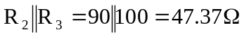
i² = 70/47.37 = 1.4777 or i = 1.2156 (which is within our range), cost = $1.65

Note that cases (b) and (c) satisfy the current range criteria and (b) is the cheaper of the two, hence the correct choice is:

R₁ and R₃

